**Loon Island Cabin Work - Summer 2019/2020**

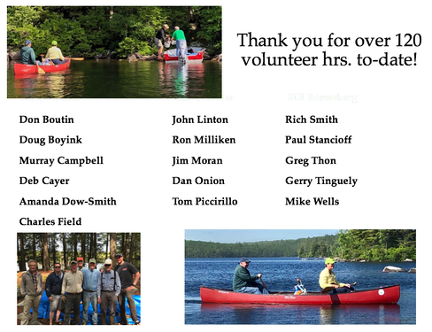

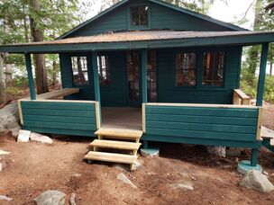

Finished Deck